**Report Q2**

1. ***Original and segmented images for flower image:***

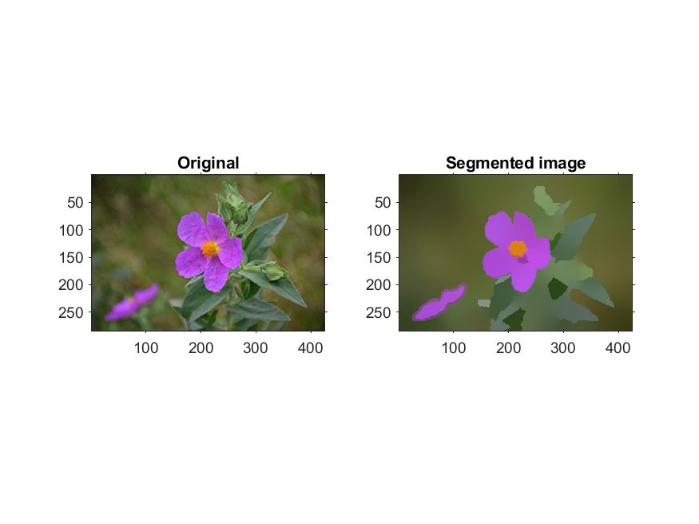

Bandwidth for color feature: 250

Bandwidth for spatial feature: 100

No. of iterations: 50

No. of Nearest Neighbors: 170

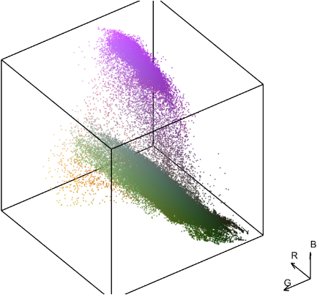 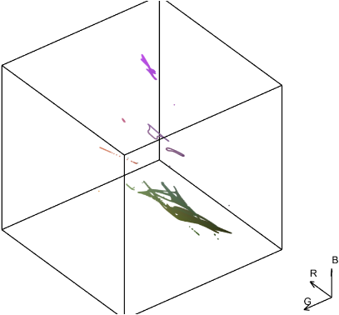

Color scatter in RGB before and after applying Mean Shift

1. ***Original and Segmented Images for bird image:***

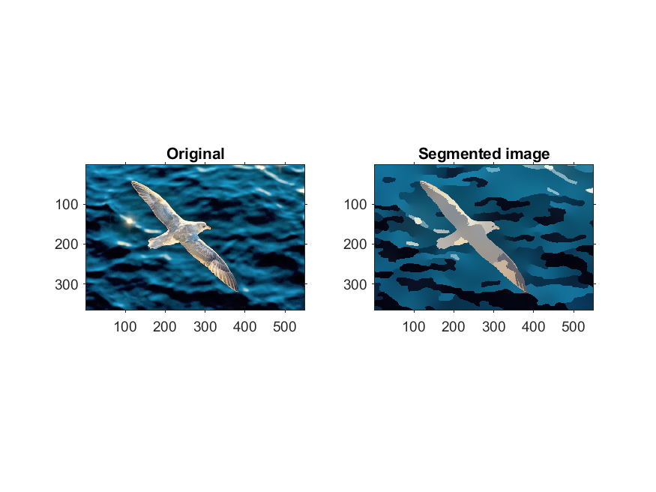

Bandwidth for color feature: 250

Bandwidth for spatial feature: 100

No. of iterations: 50

No. of Nearest Neighbors: 170

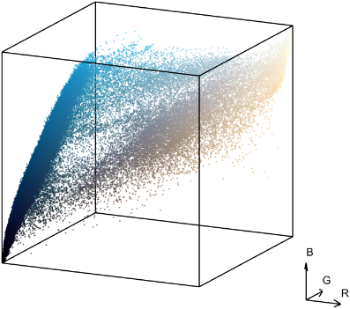 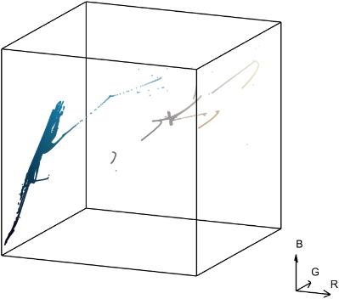

Color scatter in RGB before and after applying Mean Shift

1. ***Original and Segmented Images for baboonColor Image:***

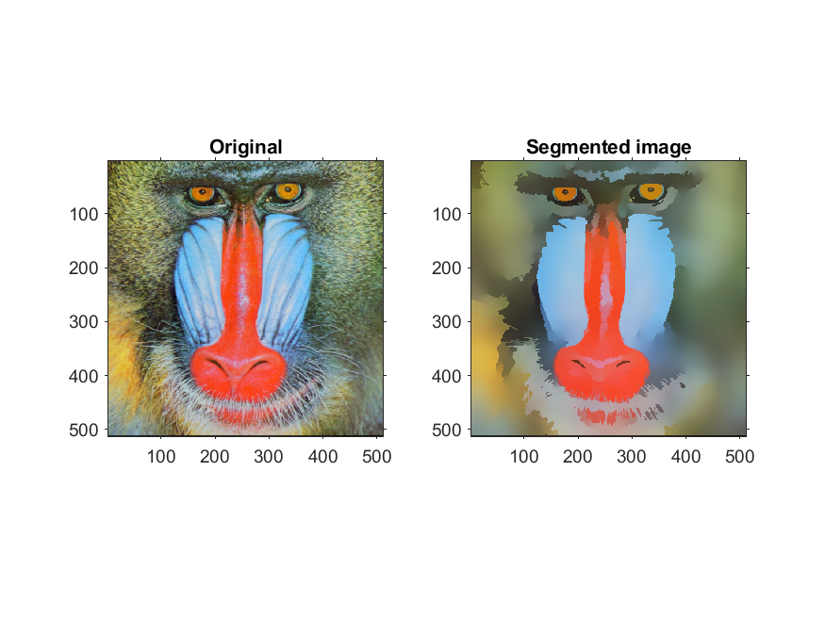

Bandwidth for color feature: 250

Bandwidth for spatial feature: 25

No. of iterations: 35

No. of Nearest Neighbors: 125

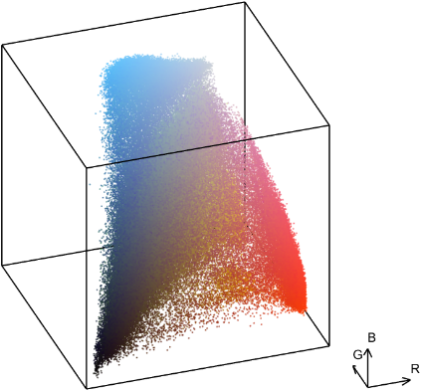 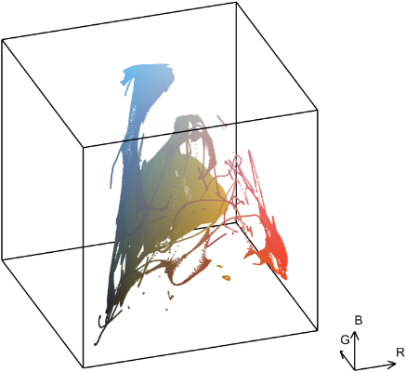

Color scatter in RGB before and after applying Mean Shift